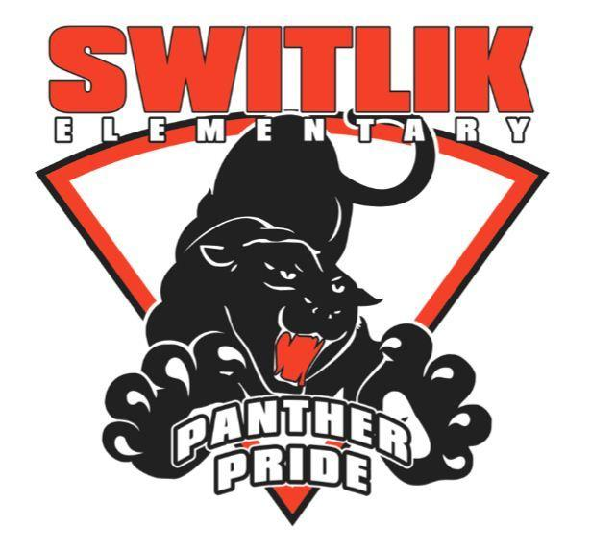 | Free & Reduced Lunch Reminder
Dear Switlik Families,
Please see important information below regarding Free and Reduced Meals:
Free and Reduced Meal Applications Should be Submitted ASAP
Although the government has made meals free for all students for the remainder of this year, all families who believe they qualify for free or reduced meal benefits should still apply so their benefits are in place at the beginning of next school year.
Please visit our Free and Reduced Meal Application Page ASAP to get your application in right away.
You can apply online and find out immediately if you qualify!

